POWER

POWER - the rate at which energy is transformed, or the rate at which work is done.

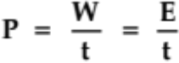

where P = the power generated (W - Watts)
W = the work done (J)
E = the energy transformed (J)
t = the time taken for the process (s)

Calculating the power developed is straightforward when there is a change in mechanical energy or work, but some situations involve movement at a constant speed which involves no change in mechanical energy.

Using W = Fs, the equation changes as follows.

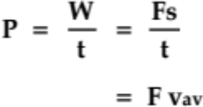

where F = average force applied (N)
v_{av} = the average velocity of the object (ms⁻¹)

EXAMPLES
1. An electric motor drives a lift of nett mass 1.47 x 10⁴ kg through a height of 27.0 m in 12.0 s. What is the power of the motor?

2. A cyclist in a road race is producing an average of 5.00 x 10² W of power whilst moving at 48.0 kmh⁻¹ along a flat road. Ignoring any air resistance, what average force is being supplied through the pedals?

